HOW TO DO A BALLET BUN
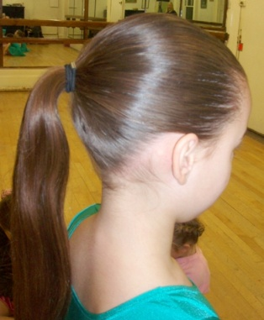
- Brush the hair back into a high ponytail. Use a little gel of hair spray to remove and wisps or bumps

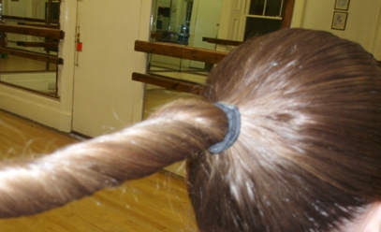
- Brush the ponytail to remove any tangles and then twist the ponytail several times

- Start to wind the ponytail around the hairband using hair grips to secure the bun to the back of the head

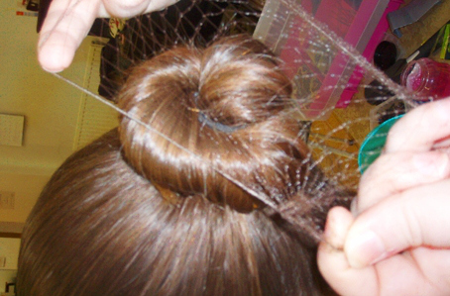

- Place a bun net which matches the hair colour over the bun and tuck under
- Use extra pins to secure the bun. Ideally the bun should be pressed flat to the back of the head.

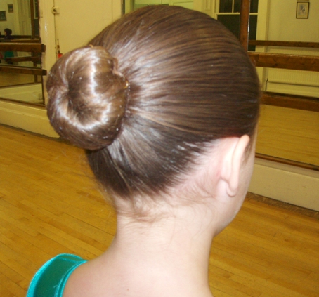
- Use extra hair spray to make sure the bun is completely secure. Any stray hair can be fastened with grips.

